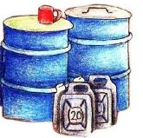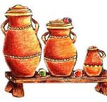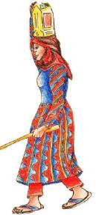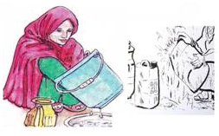

Darb 3: khuttul almeyku misada fi bikan takhuttu ley finshan ya abarbar wa dabaabin eitallufu

Darb 2: Annafu bey shu’ul altashilu almey inga bey sidada/shu’ul bisidda kan takharfu almey

Darb 1: assulu ma’awan hanak hadar takharful almey. Almaawon alwaskhan bitallif almeyku hilal sharab

**Durub ley khattatan almeyku nadif**

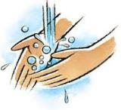

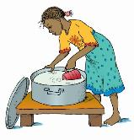

Darb 5: Assulu eidku bayl almey wal sabun ley dakharan alwasakh albiyadil waja ya imshi ley Nadim gadey

Darb 4: Ya tadussu eidku ley lubbal almey annafu bayl dalam

